Lesson Objectives:
By the end of this topic, you should be able to:
• Name the main network hardware devices and state what each one does
• Explain the difference between a hub, a switch and a router
• Describe the role of a NIC, modem, access point and gateway
• Compare copper and fibre cable types and when to use each
• Explain how data moves through hardware from a device to the Internet

Why network hardware matters
1. When you open a website on a laptop, how does the request travel from the laptop to the website?
2. When you send a document to a network printer in school, your computer and the printer needs to connect in a network for the document to print.

Why network hardware matters
Software cannot move data alone. Physical devices send, receive, direct and protect traffic.
- Connect – Link devices so they can share data.
- Direct – Send data to the right place.
- Carry – Move data quickly and reliably.
- Protect – Control who can access the network.

Network Interface Card (NIC)
A NIC is the hardware that lets a computer or device connect to a network. It can be wired (Ethernet) or wireless (Wi-Fi).
- Has a unique MAC address
- Can be wired or wireless
- Converts data into network signals
- Is built into most modern devices
- Used to be a separate expansion card

Media Access Control
Every NIC has a Media Access Control address assigned by the manufacturer.
Example of MAC address: 00:1A:2B:3C:4D:5E
12 hexadecimal digits. Written in pairs
- Unique – No two NICs should share the same MAC
- Layer 2 – Used on the local network by switches
- Mostly fixed – Can be spoofed, but not permanently changed

Every NIC has a unique MAC address (Media Access Control). Example: 00:1A:2B:3C:4D:5E
• First half (OUI) identifies the manufacturer
• Second half uniquely identifies that NIC

00:1A:2B | 3C:4D:5E
ORGANISATIONALLY UNIQUE IDENTIFIER (OUI)  - The first 24 bits (first 3 pairs)  - Identifies the manufacturer or company  - Assigned by IEEE to the organisation | UNIQUE NUMBER FOR THAT SPECIFIC NIC  - The last 24 bits (last 3 pairs)  - Unique to the network interface card (NIC)  - Assigned by the manufacturer

Most modern devices have the NIC built into the motherboard.

Wireless NIC (Wi-Fi)
- Uses radio waves – no cable to the device
- Built into almost all laptops, tablets and phones
- Connects through a Wireless Access Point
- Convenient for mobile users
- Can be affected by walls, distance and interference

NIC in the data paths

The NIC is the boundary between the device software and the physical network.

Task 1 – Network Interface Card (NIC)
Scenario: A school is setting up 20 new desktop PCs. Each PC must connect to the wired school network.
1. What hardware does each PC need to join the network? [1]

2. State the unique address that hardware uses, and explain what the two halves represent. [4]

3. Give one advantage of using a wired NIC rather than a wireless NIC for these PCs. [2]

Switches
A switch connects multiple devices on the same local network (LAN). It learns MAC addresses and forwards frames only to the correct port.
- Uses radio waves – no cable to the device
- Built into almost all laptops, tablets and phones
- Connects through a Wireless Access Point
- Convenient for mobile users
- Can be affected by walls, distance and interference
• Builds a MAC address table (which device is on which port)
• More efficient and secure than a hub
• Supports full duplex (send and receive at the same time)

Hubs
Hubs (old) send every frame to all ports, causing collisions and wasted bandwidth.
Managed switches can be configured (e.g. VLANs). Unmanaged switches are plug-and-play.

Task 2 – Switches
Scenario: A technician replaces an old hub with a switch in a classroom.
1. Explain one problem caused by using a hub that a switch solves. [3]

2. Describe how a switch decides which port to send a frame out of. [3]

3. State one difference between a managed switch and an unmanaged switch. [2]
Routers
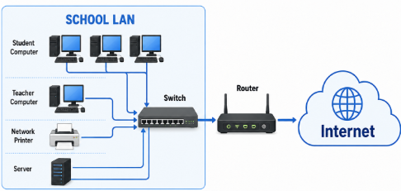

A router connects different networks and chooses the best path for data using IP addresses (Layer 3).
- Links a LAN to the Internet
- Uses a routing table
- Often provides Network Address Translation so many private devices share one public IP
- Works at Layer 3 (Network Layer)
- Uses IP addresses

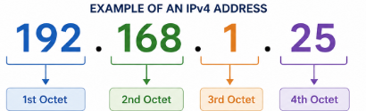

Home routers
Home routers often combine a modem, router, switch and access point in one box.
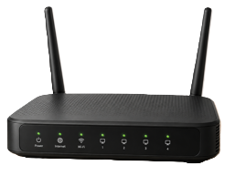
Routing table
Destination | Next hop/interface
192.168.1.0/24 | Local LAN (directly connected)
10.0.0.0/8 | Via another internal router
0.0.0.0/0 (default) | Send to the ISP (Internet Service Provider) / Internet

Network Address Translation NAT
- Network Address Translation lets many private devices share one public IP from the ISP.
- Your home devices use private addresses (e.g. 192.168.x.x)
- The router rewrites packets so they appear to come from its public IP
- Replies are mapped back to the correct internal device
- This also hides internal addresses from the public Internet
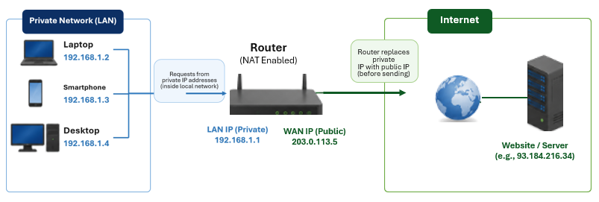
Task 3 – Routers
Scenario: A small office has one local network and needs access to the Internet.
1. Explain the main purpose of a router in this network. [3]

2. State two differences between a switch and a router. [4]

3. The office has one public IP but 15 internal devices. Name the feature that allows this and say what it does. [3]

Modems
Modem is a Modulator/Demodulator. It converts digital data into a signal suitable for the ISP link (DSL, cable or fibre) and back again.
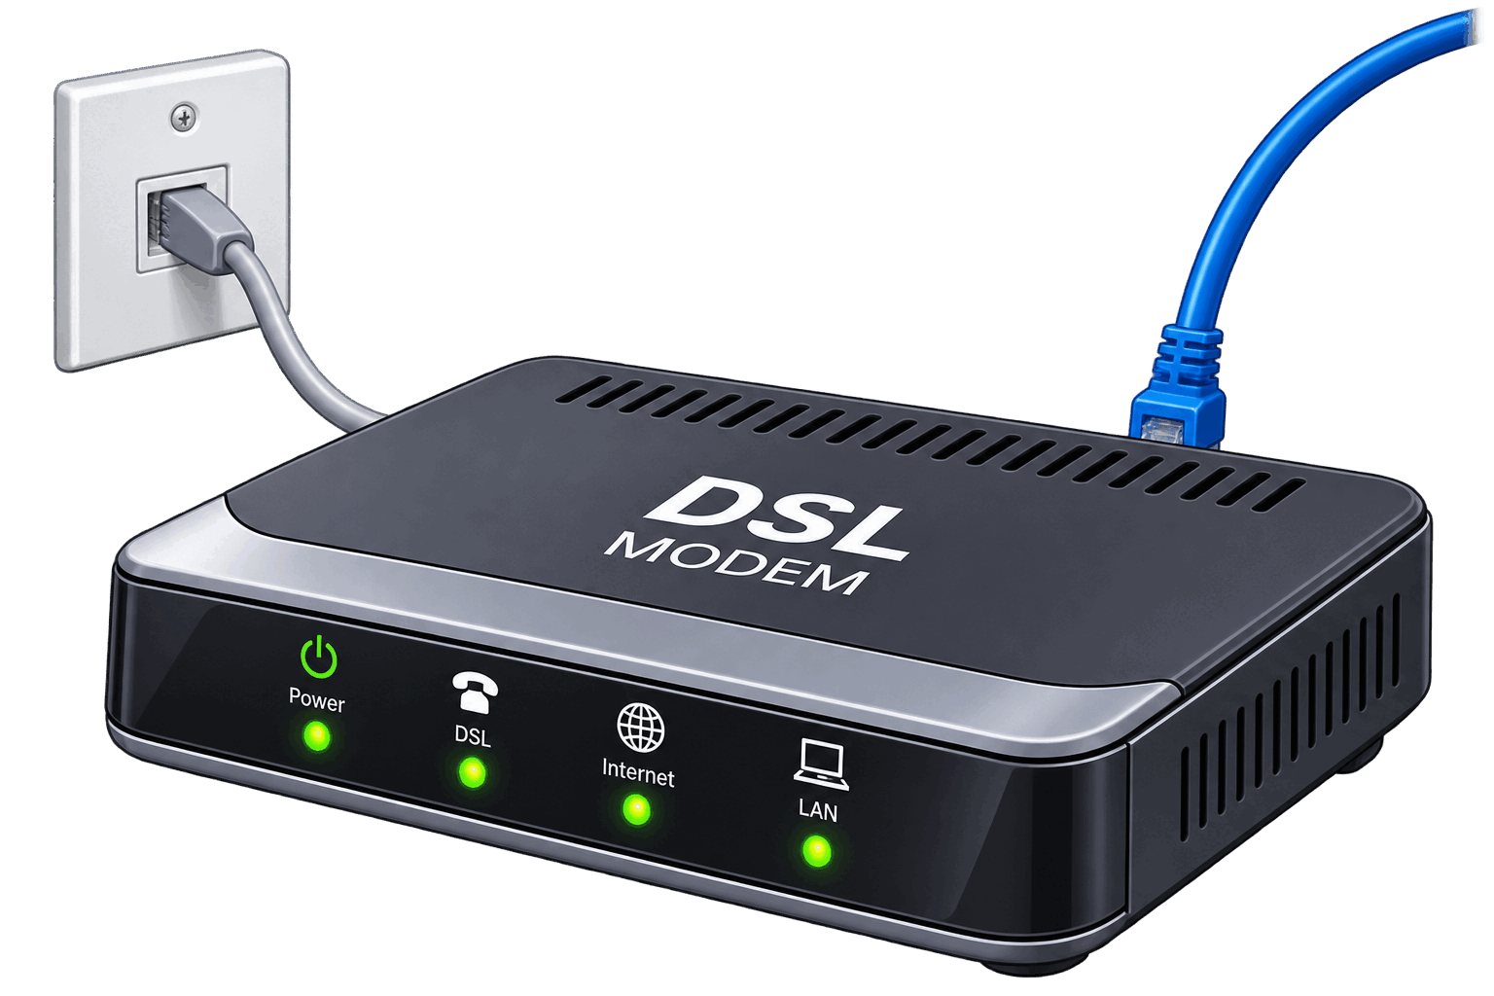
- DSL modem uses telephone line
- Cable modem uses TV cable network
- Fibre ONT - Optical terminal for fibre to the premisses

Wireless Access Point (AP)
- Access Point (AP): lets wireless devices join a wired network using Wi-Fi. Creates an SSID (network name).
- Typical path from a phone to a website:
- Phone NIC → Access Point → Switch → Router → Modem / ISP → Internet → Web server

SSID channels
SSID is the network name you see when choosing Wi-Fi.
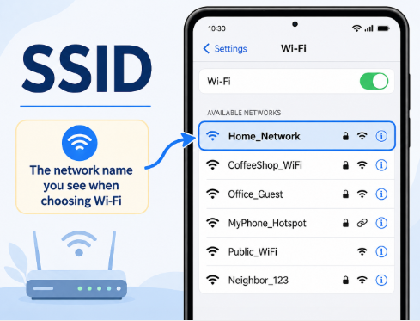 | 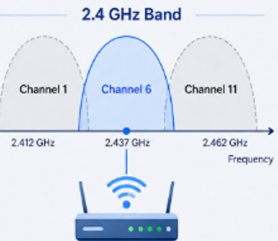

Interferences
Other APs, walls and devices can weaken the signal

Roaming
Phones switch between APs as you walk around a site
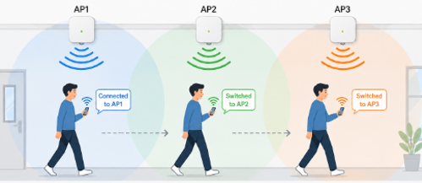
Path: phone to website
Phone wireless NIC | Sends request over Wi-Fi
Access Point | Puts traffic onto the wired LAN
Switch | Forwards toward the router
Router | Sends packet toward the Internet
Modem / ISP | Carries data onto the ISP network
Internet to Server | Server responds; path reverses

Task 4 – Modems and Access Points
Scenario: Students use phones on school Wi-Fi to open a website.
1. Name the device that creates the Wi-Fi signal students connect to. [1]

2. Explain the role of a modem in getting the school online. [3]

3. List, in order, four pieces of hardware a request from a phone might pass through before it leaves the school toward the Internet. [4]

Cables and media
Twisted pair (Ethernet): Cat5e, Cat6, Cat6a. Common for LANs. RJ-45 connector.

Why the twist
Pairs of wires are twisted to cancel electromagnetic interference.

Twisted Pair
- UTP – Unshielded Twisted Pair – most common, cheaper
- STP – Shielded Twisted Pair – extra protection in noisy environments
- RJ-45 – The plastic connector on the end of Ethernet cables

Fibre optic
- Light through glass/plastic.
- Very high bandwidth
- High speed
- For long distance
- Immune to electrical interference.

Coaxial
- It's widely used for cable television, internet connections (cable broadband), satellite TV feeds, and connecting antennas to radio or TV equipment.

Single-mode
- Narrow core
- One path for light
- Is best for long distances such as campuses and cities
- Higher-cost equipment

Multi-mode
- Wider core
- Multiple light paths
- Shorter distances (inside buildings)
- Often cheaper for short runs
Task 5 – Cables and media
Scenario: A school needs to link two buildings 1.5 km apart with a fast, reliable connection.
1. Recommend a cable type and justify with two reasons. [4]

2. State one difference between single-mode and multi-mode fibre. [2]

3. For classroom desks (short runs), which cable would you normally choose, and why? [2]

Other devices
Repeater: boosts a signal so it can travel further.
Bridge: connects two segments and only passes frames that need to cross.
Gateway: links networks (often the router); default gateway is the address used to reach other networks.
Server: provides services (files, web, login). Client: requests services (laptop, phone).
Client: Requests services or resources from a server

Server vs Client
Server | Client
Provides services: files, email, web, printing, login.  More CPU, RAM, storage and network capacity.  Often in a server room or data centre. | Requests services: laptop, phone, desktop.  Uses its NIC to reach servers and other clients across the network.
Task 6 – Other devices
Scenario: An exam question asks about less common but still important devices.
1. Describe the purpose of a repeater. [2]

2. Explain what a default gateway is and which device usually provides it. [3]

3. State one difference between a server and a client. [2]

Task 7 – Choosing devices
Scenario: A new computer room has 30 PCs, a teacher laptop, a network printer, and needs links to the school network and the Internet.
1. Which device connects all the PCs on the local network? Justify. [3]

2. Which device connects the room to the rest of the school and the Internet? [2]

3. What does each PC need to join the network, and what unique address does it have? [3]

Task 8 - Cables Hubs and Wireless
1. State one advantage of fibre optic over twisted pair. [2]

2. Explain the difference between a switch and a hub. [4]

3. Name two hardware pieces between a phone on Wi-Fi and the school main switch. [2]

Task 9 - Exam-Style Question
1. Describe the purpose of a router. [3]

2. Explain two differences between a switch and a router. [4]

3. Recommend a cable for a 2 km link between buildings and justify. [3]

Task 10 - Match up
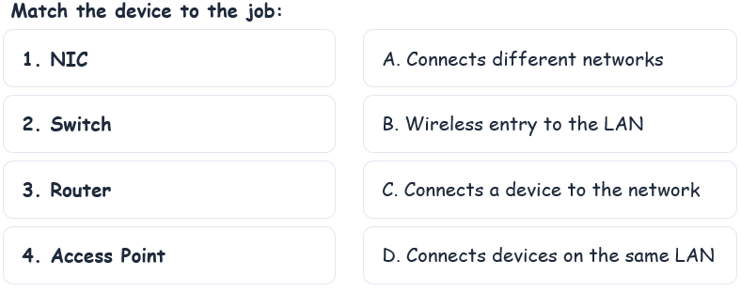

Key terms
NIC – Hardware that connects a device to a network
MAC address – Unique identifier for a NIC
Switch – Connects devices on a LAN; forwards by MAC
Router – Connects different networks; routes by IP
Hub – Old device that floods frames to all ports
Access Point – Wireless entry to a wired network
Modem – Converts signals for the ISP link
Gateway – Link between networks; often the router
Fibre optic – Light-based cable; fast and long distance
Twisted pair – Common copper Ethernet cable

