Student Booklet
Name: ______________________________________ Class: ____________ Date: ______________
Learning objectives
- Explain what PageRank is and why Google needed it.
- Work out the starting page score of every page (1 ÷ N).
- Split a page’s score across the links it sends, and add up the shares a page receives.
- Work out the base amount using the damping factor d.
- Calculate PR(X) for one round using PR(X) = base amount + d × (shares coming in).
Key ideas
Page score | 1 ÷ N, where N is the number of pages. Every page starts with the same score.
Share | page’s score ÷ number of links it sends. A page shares its score equally between all its links.
Shares coming in | Add up the shares from every page that links to the page you are scoring.
Base amount | (1 − d) ÷ N. A small score every page gets for free. d is the damping factor, usually 0.85.
PageRank | PR(X) = base amount + d × (shares coming in)
Section 1 – Page score
Page score = 1 ÷ number of pages (N). Every page starts with this score.
I DO
A web has 5 pages. Work out the page score that each page starts with.
Working out: 1 ÷ N = 1 ÷ _____ = __________
Page score = ____________
WE DO
A web has 4 pages. Work out the page score that each page starts with.
Working out: 1 ÷ N = 1 ÷ _____ = __________
Page score = ____________
YOU DO
A web has 10 pages. Work out the page score that each page starts with.
Working out: 1 ÷ N = 1 ÷ _____ = __________
Page score = ____________
Section 2 – Quick-fire: splitting and adding shares
A page shares its score equally between the links it sends: share = score ÷ number of links. A page’s new total is all the shares it receives added together.
No. | Question | Working out | Answer
1 | Page A has a score of 0.25 and sends 2 links. What does each linked page receive?
2 | Page A has a score of 0.25 and sends 4 links. What does each linked page receive?
3 | Page A has a score of 1.0 and sends 2 links. What does each linked page receive?
4 | Page A has a score of 1.0 and sends 10 links. What does each linked page receive?
5 | Page X has a score of 1.2 and sends 3 links. What does each linked page receive?
6 | Page C has a score of 0.2 and sends 4 links. What does each linked page receive?
7 | Page D has a score of 0.2 and sends 1 link. What does the linked page receive?
8 | Page A has a score of 0.125 and sends 2 links. What does each linked page receive?
9 | Website B receives shares of 0.5, 0.3 and 0.4. What is its new total?
10 | Page B receives shares of 0.1, 0.05, 0.2 and 0.1. What is its total?
Section 3 – Base amount
Base amount = (1 − d) ÷ N, where d is the damping factor and N is the number of pages.
I DO
Work out the base amount when N = 5 and d = 0.85.
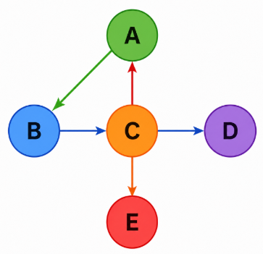
Working out: (1 − d) ÷ N = (1 − ______) ÷ ____ = ______ ÷ ____ = ________
Base amount = ____________
WE DO
Work out the base amount when N = 4 and d = 0.28.
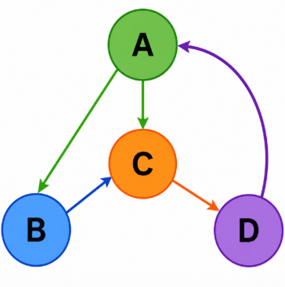
Working out: (1 − d) ÷ N = (1 − ______) ÷ ____ = ______ ÷ ____ = ________
Base amount = ____________
YOU DO
Work out the base amount when N = 10 and d = 0.75.
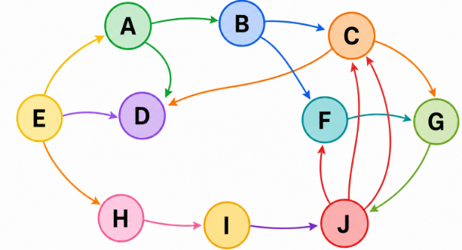
Working out: (1 − d) ÷ N = (1 − ______) ÷ ____ = ______ ÷ ____ = ________
Base amount = ____________
Section 4 – The damping factor d
1. What does the damping factor d describe, and what value does Google usually use?
___________________________________________________________________________
___________________________________________________________________________
___________________________________________________________________________
___________________________________________________________________________

2. What happens when d is high (close to 1)?
___________________________________________________________________________
___________________________________________________________________________
___________________________________________________________________________
___________________________________________________________________________

3. What happens when d = 0?
___________________________________________________________________________
___________________________________________________________________________
___________________________________________________________________________
___________________________________________________________________________

Section 5 – Working out a PageRank
Follow the six steps every time. Look carefully at how many links each page sends — it is not always 2!
Worked example – Work out PR(C)
I DO
A web has 4 pages: A, B, C and D.  The links are:  A → B A → C B → C  C → A D → C  The damping factor is d = 0.85.  Work out PR(C) for one round. | 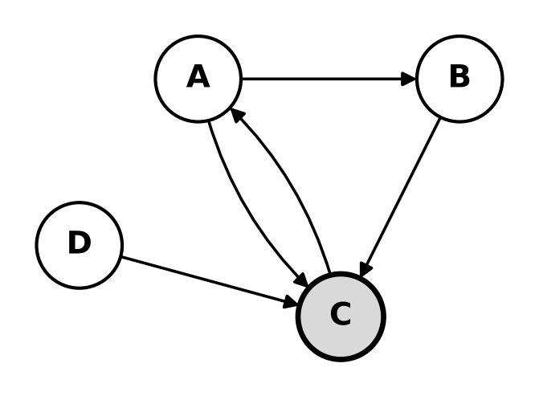
Step 1 Page score
1 ÷ N = 1 ÷ ____ = __________
Step 2 Which pages link to C?
________________________________________
Step 3 Work out the share each of those pages sends to C
Page | Its score | Links it sends | Share = score ÷ links
Step 4 Add the shares coming into C
Total shares coming in = ______________________________________________
Step 5 Base amount
(1 − d) ÷ N = (1 − ______) ÷ ____ = __________
Step 6 PR(C) = base amount + d × (shares coming in)
PR(C) = _________ + 0.85 × _______ = _________ + _________
PR(C) = ______________
Task 1 – Work out PR(E)
A web has 5 pages: A, B, C, D and E.  The links are:  A → B A → E B → C  B → E C → D C → E  D → A D → E E → B  The damping factor is d = 0.85.  Work out PR(E) for one round. | 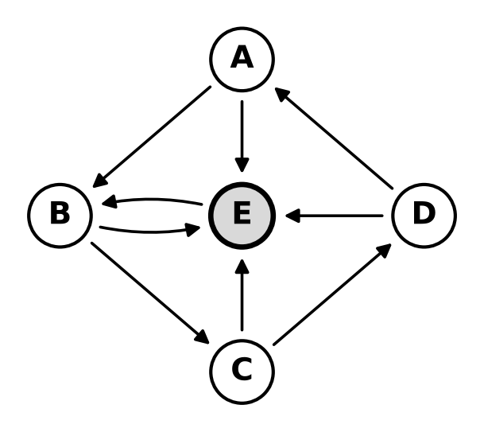
Step 1 Page score
1 ÷ N = 1 ÷ ____ = __________
Step 2 Which pages link to E?
________________________________________
Step 3 Work out the share each of those pages sends to E
Page | Its score | Links it sends | Share = score ÷ links
Step 4 Add the shares coming into E
Total shares coming in = ______________________________________________
Step 5 Base amount
(1 − d) ÷ N = (1 − ______) ÷ ____ = __________
Step 6 PR(E) = base amount + d × (shares coming in)
PR(E) = _________ + 0.85 × _______ = _________ + _________
PR(E) = ______________
Task 2 – Work out PR(H)
A web has 8 pages: A, B, C, D, E, F, G and H.  The links are:  A → B A → H B → C  C → D C → H D → E  E → F E → H F → G  G → A G → H H → B  The damping factor is d = 0.85.  Work out PR(H) for one round. | 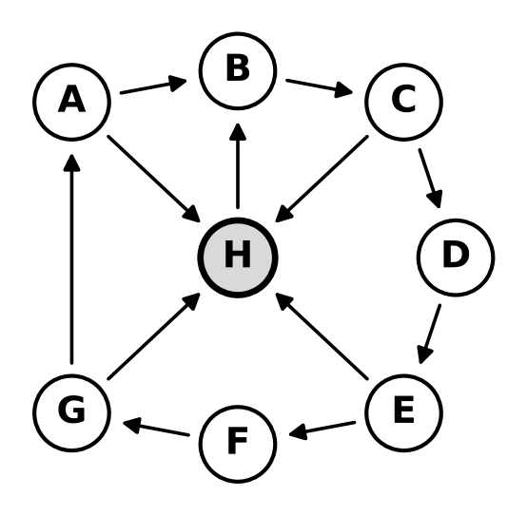
Step 1 Page score
1 ÷ N = 1 ÷ ____ = __________
Step 2 Which pages link to H?
________________________________________
Step 3 Work out the share each of those pages sends to H
Page | Its score | Links it sends | Share = score ÷ links
Step 4 Add the shares coming into H
Total shares coming in = ______________________________________________
Step 5 Base amount
(1 − d) ÷ N = (1 − ______) ÷ ____ = __________
Step 6 PR(H) = base amount + d × (shares coming in)
PR(H) = _________ + 0.85 × _______ = _________ + _________
PR(H) = ______________
Task 3 – Work out PR(D)
A web has 5 pages: A, B, C, D and E.  The links are:  A → B A → C A → D  A → E B → D C → B  C → D D → A E → D  The damping factor is d = 0.85.  Work out PR(D) for one round. | 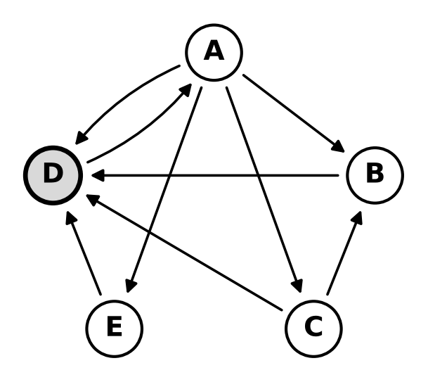
Step 1 Page score
1 ÷ N = 1 ÷ ____ = __________
Step 2 Which pages link to D?
________________________________________
Step 3 Work out the share each of those pages sends to D
Page | Its score | Links it sends | Share = score ÷ links
Step 4 Add the shares coming into D
Total shares coming in = ______________________________________________
Step 5 Base amount
(1 − d) ÷ N = (1 − ______) ÷ ____ = __________
Step 6 PR(D) = base amount + d × (shares coming in)
PR(D) = _________ + 0.85 × _______ = _________ + _________
PR(D) = ______________
Task 4 – Work out PR(B)
A web has 5 pages: A, B, C, D and E.  The links are:  A → B A → D B → A  C → A C → B C → D  C → E D → B E → B  E → C  The damping factor is d = 0.85.  Work out PR(B) for one round. | 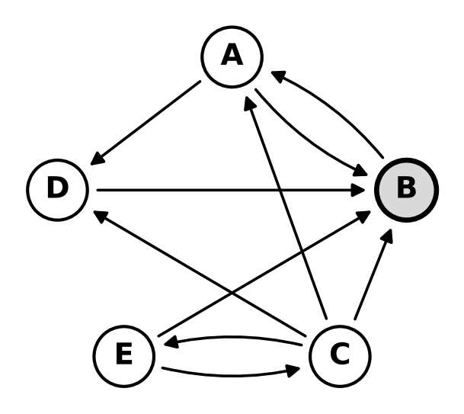
Step 1 Page score
1 ÷ N = 1 ÷ ____ = __________
Step 2 Which pages link to B?
________________________________________
Step 3 Work out the share each of those pages sends to B
Page | Its score | Links it sends | Share = score ÷ links
Step 4 Add the shares coming into B
Total shares coming in = ______________________________________________
Step 5 Base amount
(1 − d) ÷ N = (1 − ______) ÷ ____ = __________
Step 6 PR(B) = base amount + d × (shares coming in)
PR(B) = _________ + 0.85 × _______ = _________ + _________
PR(B) = ______________
Extension – Work out PR(J)
A web has 10 pages: A, B, C, D, E, F, G, H, I and J.  The links are:  A → B A → J B → C  C → D C → J D → E  E → F E → J F → G  G → H G → J H → I  I → A J → A  The damping factor is d = 0.85.  Work out PR(J) for one round. | 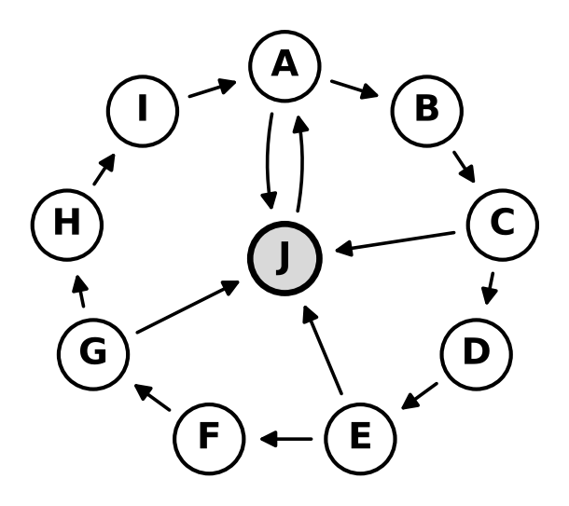
Step 1 Page score
1 ÷ N = 1 ÷ ____ = __________
Step 2 Which pages link to J?
________________________________________
Step 3 Work out the share each of those pages sends to J
Page | Its score | Links it sends | Share = score ÷ links
Step 4 Add the shares coming into J
Total shares coming in = ______________________________________________
Step 5 Base amount
(1 − d) ÷ N = (1 − ______) ÷ ____ = __________
Step 6 PR(J) = base amount + d × (shares coming in)
PR(J) = _________ + 0.85 × _______ = _________ + _________
PR(J) = ______________

